
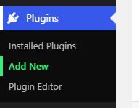

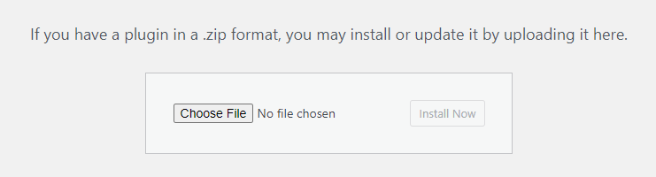

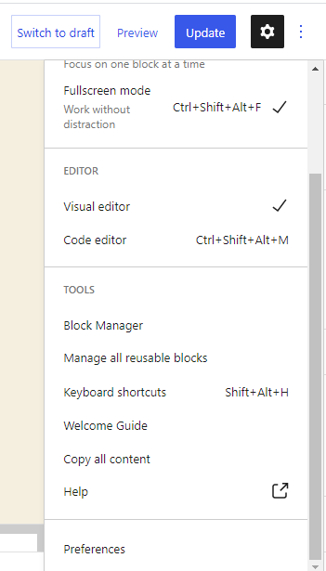
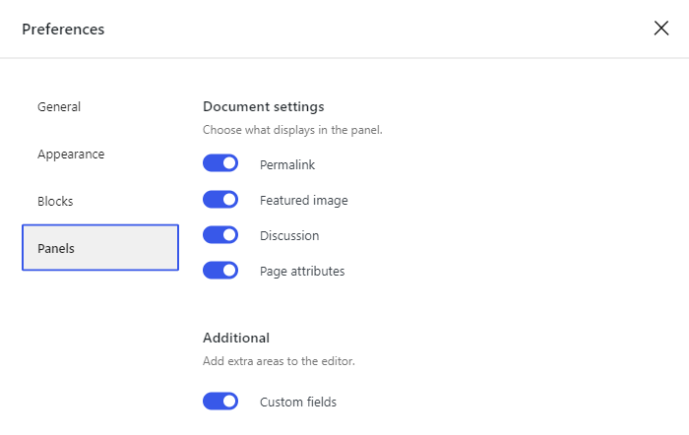
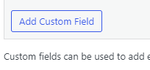
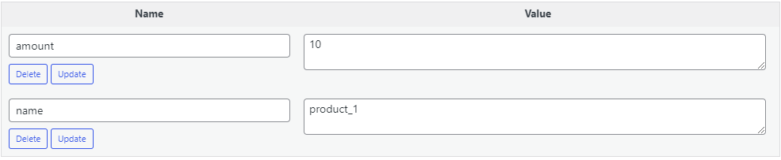

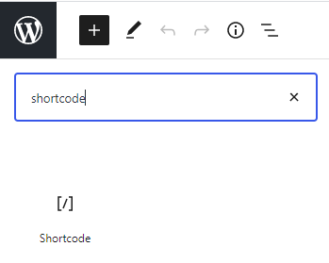
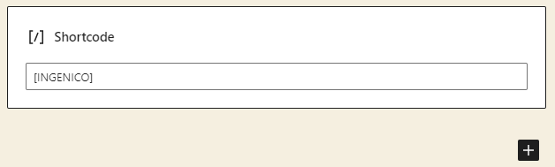


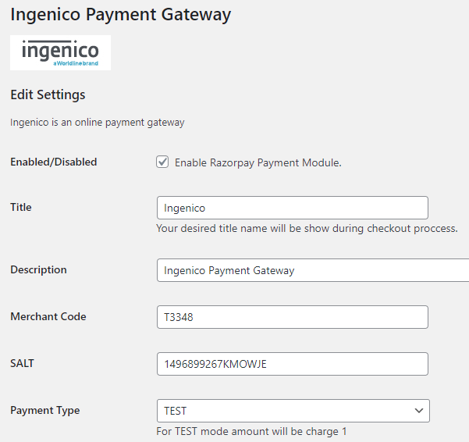
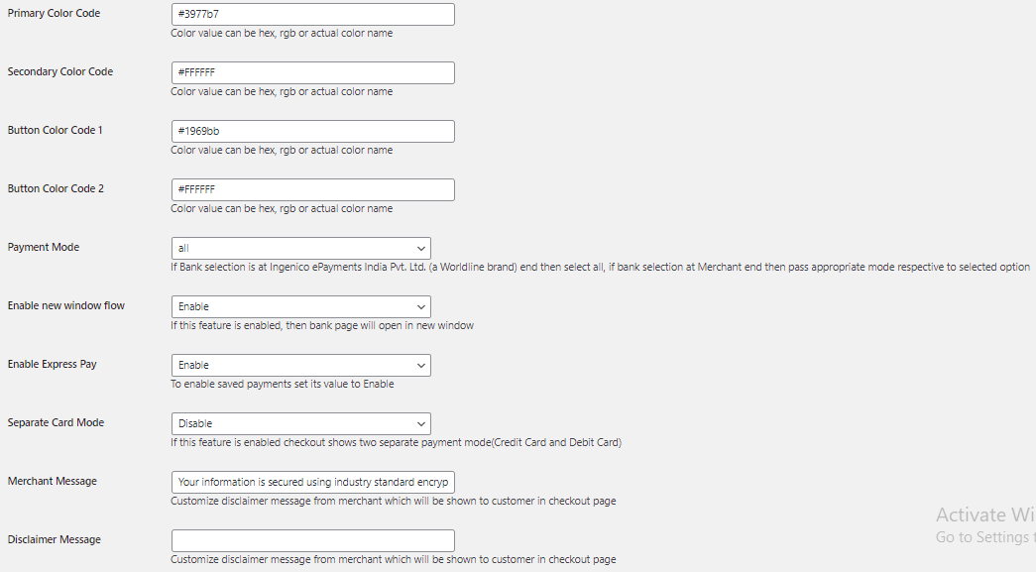

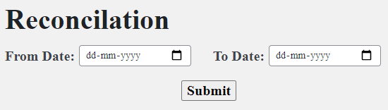


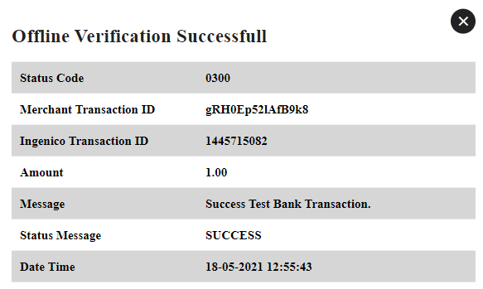
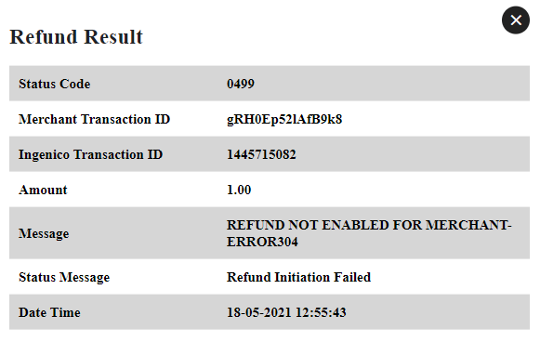


INSTALLATION MANUAL

Table of Contents

Applicable Version..………………………….…………………….….1

Installation....………………………….……….………………………1

How to Use it.…………………………………………………….……3

Update Plugin…………………………………………………….……6

Configuring worldline……………………………………………….…6

Feature List………………………………………………………….…8

Documentation Link……………………………………………….….11

APPLICABLE VERSIONS

Applications | Versions
PHP | 7.x to 7.4.x
Wordpress | 5.0.0.x to 5.6

INSTALLATION & UPGRADE

Please follow the given steps to install and run the worldline Payment Gateway Standalone module

- Login to site admin in wordpress site

- After successful login, we will find a menu bar at the left side of the corner. Go to Plugins menu select ‘Add New’ option.

- Click the ‘Upload Plugin’ button.

- Browse the provided zip folder and click on the ‘Install Now’ button.

- After successful install click on ‘Activate Plugin’ link.

- Click on worldline which is on the menu bar to access the setting page

HOW TO USE IT?
To use the plugin, Merchant need to add the custom field for product, to do so

- Go to Edit mode of your wordpress page

- Click on the option (3 dots) which is on the top-right corner of the page and click on preferences

- The preferences window will appear like this and then enable Custom fields

- On enabling custom filed, the page will show options to add customs field, click on Add Custom Field

- Add 2 custom fields name and amount of the product and set the value for that, the worldline Module will take the value from this custom field
Note : If Customs filed not set properly then name will be considered as null and amount will be considered as 1.

- After Step 5, add the shortcode to display the worldline Payement Button on the screen

- To add shortcode, Click on Add block button and search for shortcode, and add it

- Type [worldline] in the shortcode field

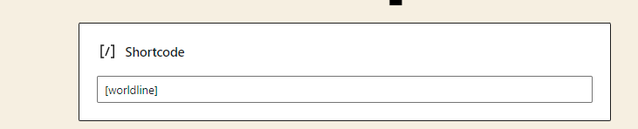

- Click on Update

- On Successfull addition of shortcode, The PAY WITH worldline button will appear on the screen.


UPDATE PLUGIN

- Go to the ‘Plugins’ in the left admin Menu, select the worldline Plugin and Click Deactivate link.

- After Deactivation, ‘Delete’ the plugin and Upload the new plugin->Install->Activate.

CONFIGURING worldline

- Go-to admin panel.

- Click on worldline menu shown above to access the setting page



- Configure it as below:

Column Name | Description
Enabled | Click on the checkbox in order to Enable worldline
Merchant Code | Enter Merchant Code
Salt | Enter Salt.
Payment Type | For Test mode Select ‘Test’ and for Live mode select ‘Live’
Merchant Scheme Code | Enter Scheme Code

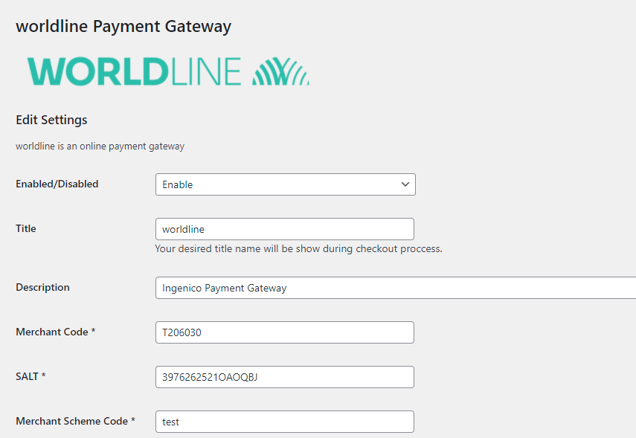

- Now click on “Save Changes” on the bottom-left corner.
- worldline Payment Gateway is now configured & ready to use.

Advanced Configuration

There are also some advanced configuration options you may consider as shown below:

FEATURES LIST

Dual verification of response:
We are validating responses with a hash value and call again Payment Gateway for dual verification from the payment gateway before updating to the order status.
Reconciliation
Merchants can update the pending status of the order automatically if the payments are successful. This page can be found under Left Admin menu > worldline Reconciliation



On clicking the button the reconciliation page will appear on the screen like this where merchant need to enter the date for reconciliation.

Logs request and response

Daily new file creates for the logs request and response from the server for future reference.

S2S Verification

If we do not receive any response from the payment gateway then after 30 mins, we will get a response from the server and based on the response it will update order status.
To configure S2S URL, contact prod team.

S2S url format : hostname/wp-json/worldline/s2sverification
S2S url example :http://example.com/wp-json/worldline/s2sverification

MCG

It supports the multi currency like USD, GBP, SGD and a lot more.

worldline Offline Verification

Merchants can verify the status of their payment by using the Payment Verification page. The payment verification can be found on worldline Order page which can be accesed by clicking the worldline Order present in the menu bar.


Where details of each generated order will get displayed in a tabular format and against each order there will be two buttons on the right-most side
1. Online Verification
2. Refund
E.g.

So Merchant can verify the status of their payment just by clicking on the buttons against the order, merchant need to verify.

When the merchant clicks on the Online Verification button the popup window will get appeared on the screen and the result of the online verification will get displayed on the popup

Refund

Merchants should be able to process the refund online for the order whose payment has been done via worldline.
To refund an order merchant needs to click on the refund button of the specific order and the popup window will get displayed on the screen with the result of the refund

Embed Payment Gateway

After enabling this setting, payment gateway displays like embedded on the page instead of pop-up so user experience would be good.

Documentation link
https://www.tecprocesssolution.com/proto/p2m/client/salt-based-documentation.htm#online

